Test project for agricultural logistics
On and off-road tanker trailer from Fliegl

The connecting road – fields are becoming more and more important in agricultural logistics. Vehicles, which can be used both on asphalt as well as off-road can be used to increase transport efficiency and reduce operating costs. In a test project Fliegl Agrartechnik (agricultural technology) and Paul Nutzfahrzeuge (utility vehicles) have designed and built a tractor-trailer, that can operate quickly and unobtrusively on the road, but can take on tasks in the fields and meadows.

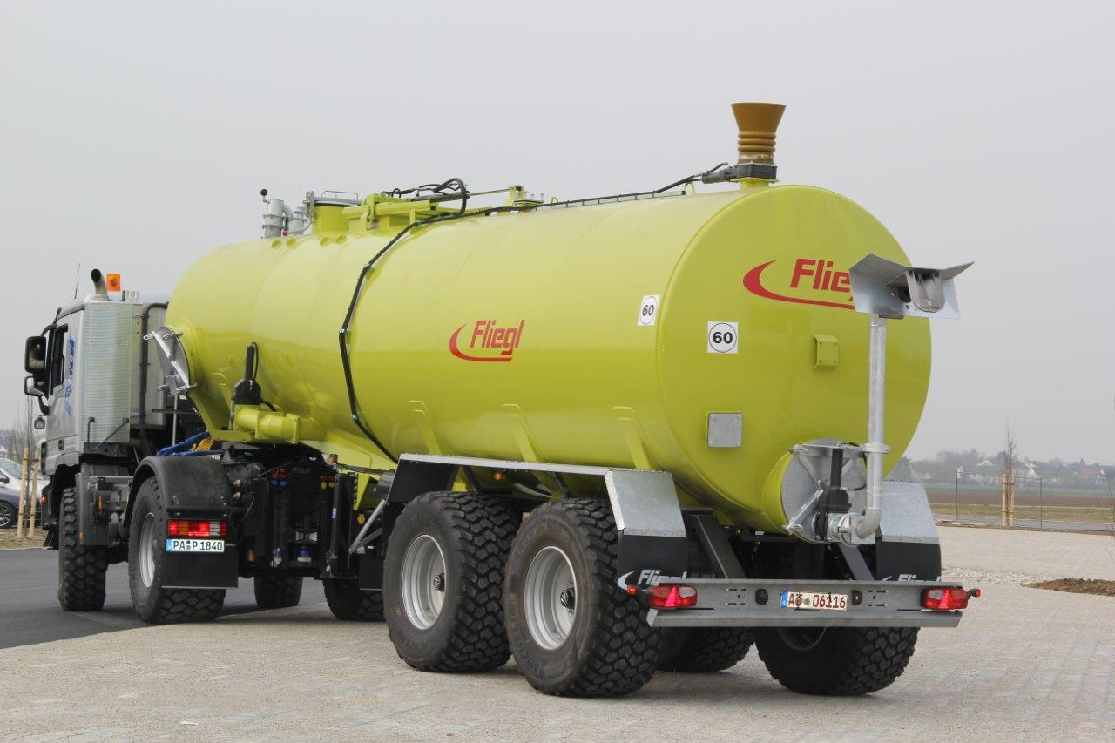

The combination consists of a 456 hp four-wheel-drive Mercedes-Benz Actros 1846 AK and a 30,000 litre semi-trailer designed for transporting and spreading liquid manure. Both roll along on extra wide rough tread terra tyres designs, such as the Michelin CargoXBib, which are distinguished by their smooth running in road traffic, while having strong grip off-road.

The pneumatically sprung trailer has been adapted to the coupling height of 1630 mm and fitted with a 2 inch kingpins. Its specially designed tank from gives it a low centre of gravity, that gives it good handling characteristics both on the roads as well as on unpaved surfaces.

The conversion of the double-axle truck includes, amongst other things, a load sensing hydraulic system and the installation of an Isobus terminal, so there is a reliable connection with the semi-trailer tanker and comfortable operation is guaranteed from the driver's seat of the HGV. The tractor-trailer has been approved for a maximum speed of 60 kilometres per hour, which can be verified on a TÜV data sheet. If the Slurry Tanker is not required, the Actros could, for example, be used to pull push-off trailers or municipal trailers. In addition to the fifth wheel coupling there is also has a 40 millimetre straight drawbar and a K80 ball head coupling. With various changes of the trailers and semi-trailers quickly between jobs in agriculture, forestry and on construction sites, the HGV maintains maximum flexibility.

The equipment of this semi-trailer tanker from Fliegl includes:

- A dual-circuit compressor unit with automatically load sensitive brake pressure regulator (ALB)
- 420 180 brake drums
- A heat-resistant vacuum compressor with a delivery rate of 12,000 litres per minute
- A 24 volt lighting system
- A filling dome with a diameter of 400 millimetres.
- A 700 x 550 millimetre hydraulic sliding cover
- Semi-trailer support jack
- A docking unit with a riser, 200 millimetre rubber funnel and a hydraulic 8-inch valve
- A distributor head

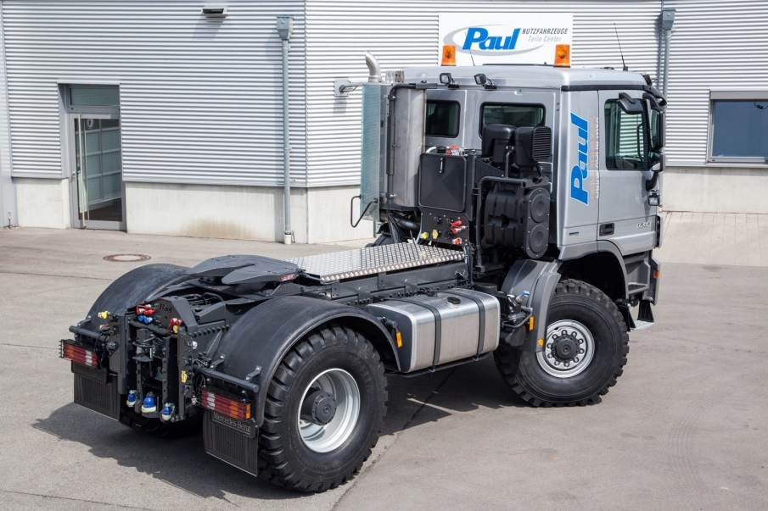

Technical data of the Actros 1846 4x4 Agricultural:

- Technical axle load 7.5 or 11.5 tonnes
- Fifth wheel coupling loading 7.8 tonnes
- K80 loading 3 tonnes
- Wheelbase 3530 millimetres
- 456 hp 6 cylinder Euro engine
- Vehicle width approx. 2550 millimetres
- Rear PTO up to 3000 Newton metres
- Top speed 70 kph

Conversion by Paul Nutzfahrzeuge, including:

- Flexible adjustable rear axle mud guards
- 75 cubic centimeter load sensing hydraulic system, joystick, 3 double-acting proportional cells
- Rear PTO with offset drive and oil cooling
- Hand driven with Potentiometer for Speed Control
- PTO shaft protector
- Working lights

Advanced agricultural technology in new directions - with the semi-trailer tanker Fliegl can bring 30,000 litres of liquid manure via the roads into the fields - quickly and economically, as contemporary agricultural logistics requires.

______________________________________

The Fliegl Group has been successful as an international manufacturer of agricultural and commercial machines and accessories, for over 30 years. At www.fliegl.com customers can quickly find the right products and then receive a customized offer. More than 800 employees in the Fliegl manufacturing centres in Kastl, Triptis, Töging (Germany), Abda (Hungary) and Vilafranca (Spain) manufacture quality products for agriculture, transportation, construction, garden and landscaping and municipalities. Sales and distribution centers across Europe, in Kastl, Triptis and Töging (Germany), Abda (Hungary), Bosca (Romania), Komàrno (Slovakia), Krnov (Czech Republic), Vilafranca near Barcelona (Span) and additional company representatives ensure the rapid availability of products and services. The Agricultural Centre in Kastl provides spare parts for all Fliegl products on an area of 25,000 m², as well as other commodities for house, farmyard, stable and garden. You can purchase directly on site, or order via the Internet (www.agro-center.de) and then have your order quickly delivered.

